

Assignment 2

- College: College of Computing
- Major: Computer Science
- Supervisor: Man Hon Michael CHEUNG
- Student Name: CHEN Xian
- Student Number: 5xxxx

Chapter 3
P8. Draw the FSM for the receiver side of protocol rdt3 . 0.
ANS:
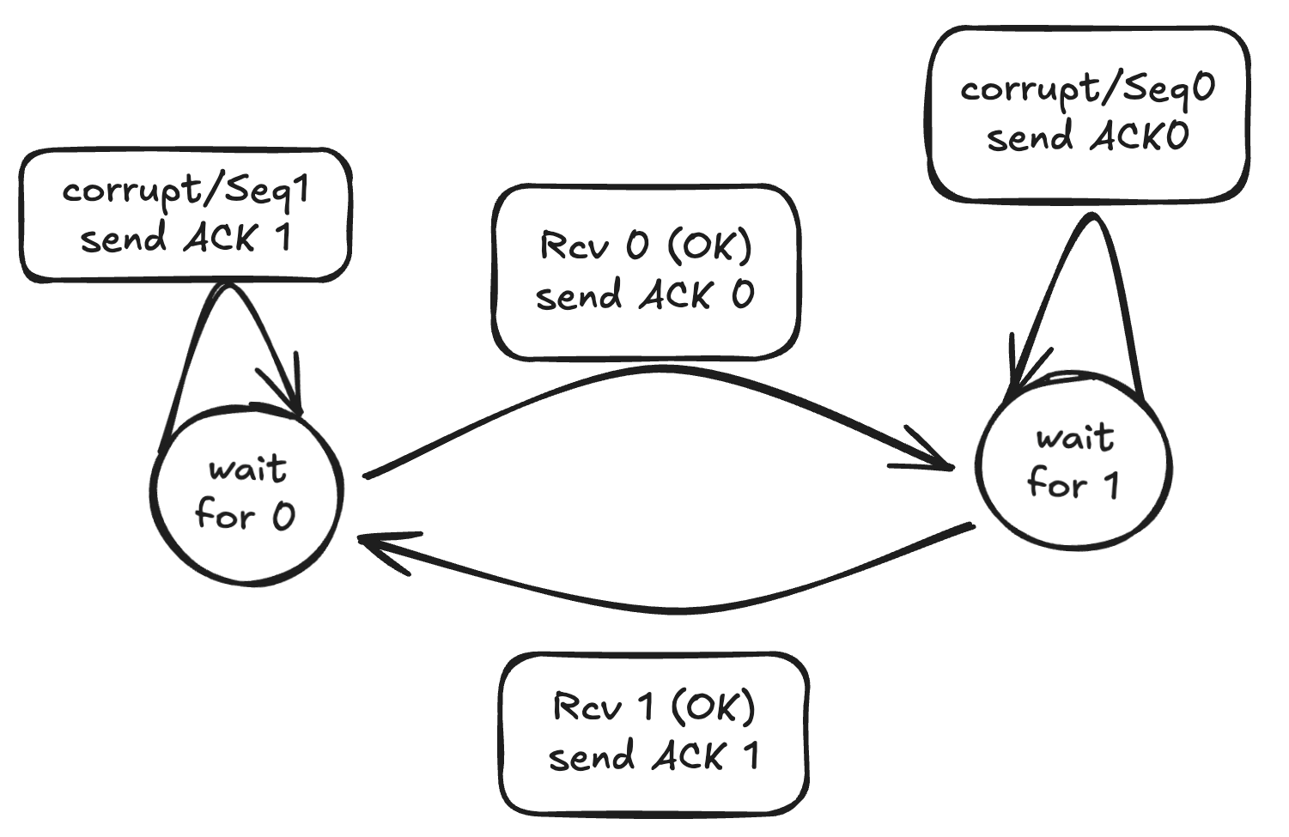

P22. Consider the GBN protocol with a sender window size of 4 and a sequence number range of 1,024. Suppose that at time t, the next in-order packet that the receiver is expecting has a sequence number of k. Assume that the medium does not reorder messages. Answer the following questions:
- What are the possible sets of sequence numbers inside the sender's window at time f? Justify your answer.
- What are all possible values of the ACK field in all possible messages currently propagating back to the sender at time t? Justify your answer.
ANS:
a.:
[k-4, …, k-1]
[k-3, …, k]
[k-2, …, k+1]
[k-1, …, k+2]
[k, …, k+3]
There are two cases:1. The sender has already received ACK $k-1$sent by the receiver. In this case, the sender’s window slides forward, and its base becomes $k$. The sender window range is $\left[k, k+3\right]$. 2.Although the receiver has received packet $k-1$and sent ACK $k-1$, this ACK (and possibly earlier ACKs) may still be in transit, so the sender has not yet received it. For the sender to still be able to send packet $k-1$, its window must contain $k-1$. Therefore, the oldest possible window that can still include $k-1$is $\left[k-N, k-1\right]$, where $N$is the window size.

b.:
ACK$∈\{k-4, k-3, k-2, k-1\}$
you can also get the reason from the answer a.

Chapter 4&5
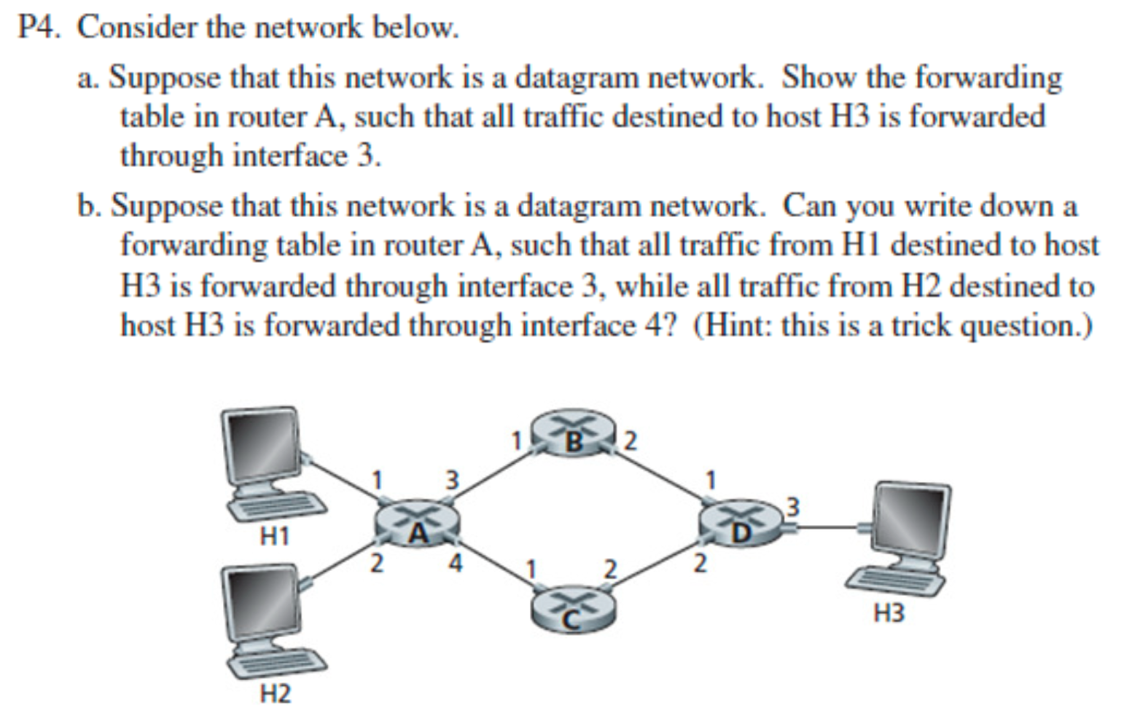
ANS:
a.:
Destination Address | Link Interface
H3 | 3
b.:
No. In the forwarding table, it cannot distinguish the source.

Paper reading
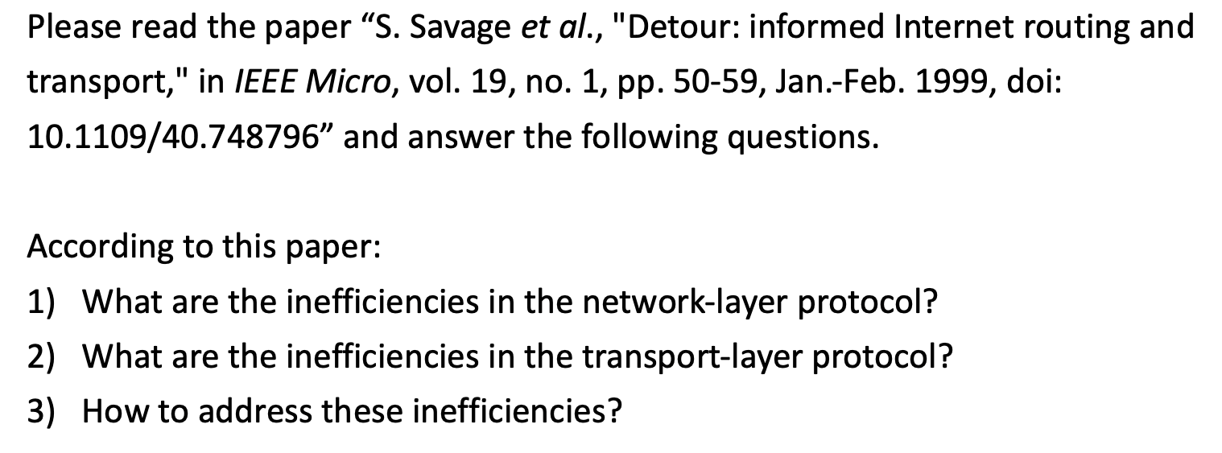
ANS:
(1): The main inefficiency in the network layer is that routing paths are often not optimal. For instance, in Internet routing, it is common to see that sending traffic from $A→B→C$ is faster than sending it directly from $A→C$.
(2): The inefficiencies of the transport layer are primarily reflected in its slow adaptation to network conditions and its handling of non-congestion losses.
For instance, its slow connection establishment and misinterpreting packet loss for TCP and slow startup.
(3): To address these inefficiencies, the paper proposes the Detour architecture, an early form of intelligent overlay networking. Detour builds a logical routing layer on top of the existing Internet and deploys smart Detour nodes that continuously measure performance metrics and dynamically choose better paths. Instead of sending packets directly to the destination, traffic can be tunneled through an intermediate node when that alternative path provides better performance, effectively bypassing congested or suboptimal Internet routes. The architecture also incorporates transport-layer optimizations in long-distance tunnels, such as splitting end-to-end connections to enable faster local retransmissions and make the system more robust to non-congestion losses. Together, these mechanisms significantly improve overall network performance.

